**Appia Technical Test**

Welcome to the Appia Technical Test. This test consists of one design and programming exercise and two essay questions. You are free to use any publicly available Java or open source APIs. Research is acceptable, but plagiarism will not be tolerated.

The design and programming exercise is to create a random poem generator using the following grammatical rules:

POEM: <LINE> <LINE> <LINE> <LINE> <LINE>

LINE: <NOUN>|<PREPOSITION>|<PRONOUN> $LINEBREAK

ADJECTIVE: black|white|dark|light|bright|murky|muddy|clear <NOUN>|<ADJECTIVE>|$END

NOUN:

heart|sun|moon|thunder|fire|time|wind|sea|river|flavor|wave|willow|rain|tree|flowe

r|field|meadow|pasture|harvest|water|father|mother|brother|sister

<VERB>|<PREPOSITION>|$END

PRONOUN: my|your|his|her <NOUN>|<ADJECTIVE>

VERB:

runs|walks|stands|climbs|crawls|flows|flies|transcends|ascends|descends|sinks

<PREPOSITION>|<PRONOUN>|$END

PREPOSITION:

above|across|against|along|among|around|before|behind|beneath|beside|between|beyon

d|during|inside|onto|outside|under|underneath|upon|with|without|through

<NOUN>|<PRONOUN>|<ADJECTIVE>

 To the left of the colon is the name of the rule

 To the right of the colon is the rule definition which can consist of words, keywords and references to other rules.

 A reference to another rule is marked with angle brackets, for example <NOUN>. Rules can reference themselves, making them recursive.

 Keywords are marked with $. There are two keywords: LINEBREAK and END. LINEBREAK adds a line break to the output, END marks that the end of a line has been reached.

This means that a line can only end with an adjective, a noun or a verb.

 A grouping of elements separated by | means that one of those elements should be selected at random.

 Anything else that is plain text can be considered a word, for example murky or heart.

For example, the rule PRONOUN is defined as my|your|his|her <NOUN>|<ADJECTIVE> which means that one of the words my, your, his or her should be selected at random followed by either a NOUN or an ADJECTIVE, also selected at random.

1) Write a Java program which parses the grammatical rules from a text file, then uses the parsed data to generate a random poem. Here is an example of what the output might look like:

my sun among her white meadow

moon upon my light

moon

your rain climbs

her murky bright clear willow

2) Create a class diagram which describes the design used in the implementation of question 1.

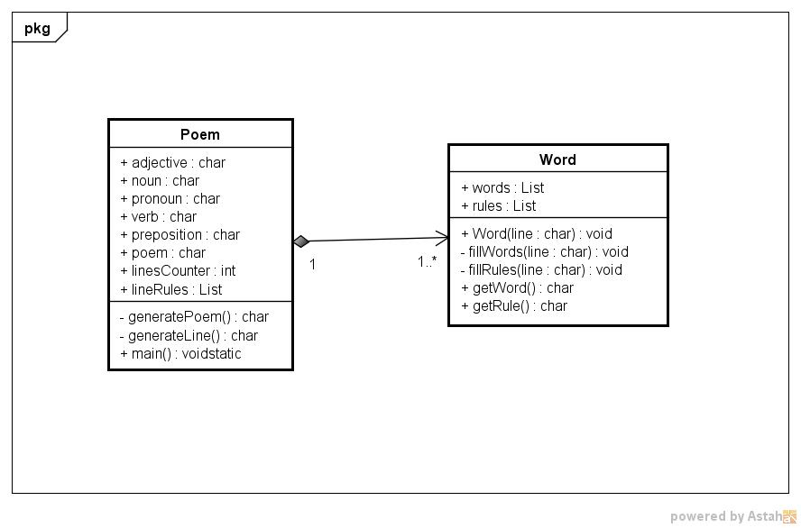

3) Explain two cases where you learned something through experience (e.g. solving a production issue) and could not have learned about that problem through theoretical knowledge or reading through technical documentation.

*R/ * Development estimation, you can read a lot about estimation techniques but that's something that only can be valid if you know yourself and how do you work.*

*\* Be practical, sometimes what clients need is not what you are thinking, even sometimes is not a new implemented software solution. I had this case and what they needed was a simple Excel sheet.*

4) Given the choice between writing ideal code and meeting a critical deadline, which would you choose and why?

*R/ Depends of the cost that means for the project, by my side always try to bring the code to its best and try conciliate deadlines; I preffer happy clients than clients comming back to me for fix issues.*